
Details:
Roll Number: DA25M502
Name: Amardeep Kumar
Software Requirements:
Docker and Apache Kafka: 7.6.0

Part A

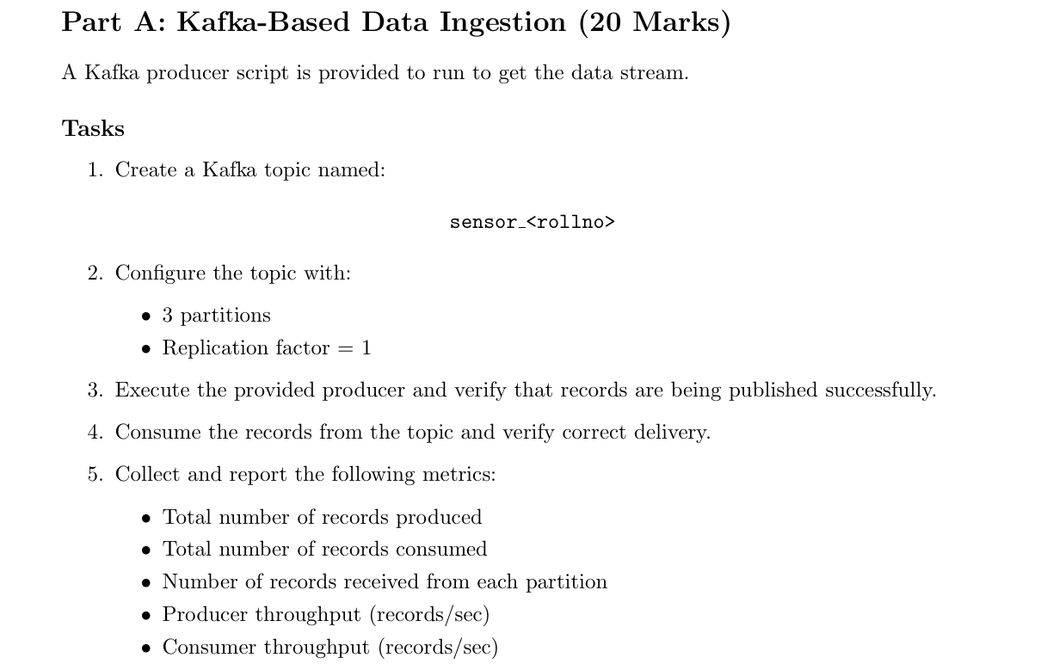
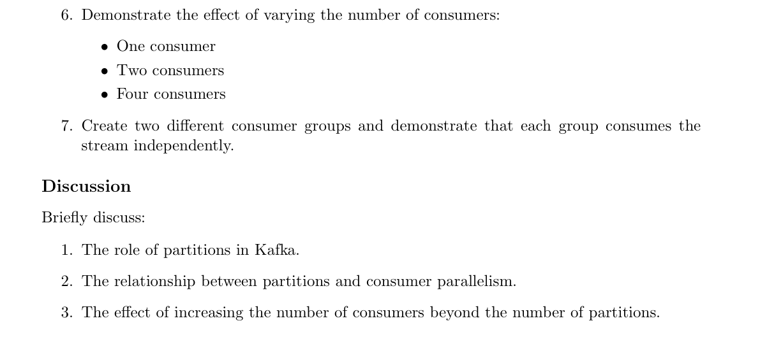


# 1. Create Kafka topic and 2. Configure the topic
docker exec -it docker-kafka-1 bash
kafka-topics --bootstrap-server localhost:9092 --create --topic sensor_da25m502 --partitions 3 --replication-factor 1
Confirmed the configuration:
kafka-topics --bootstrap-server localhost:9092 --describe --topic sensor_da25m502
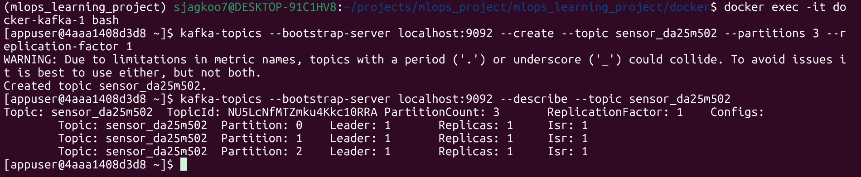

# 3. Execute the provided producer and verify that records
python producer.py --topic sensor_da25m502 --records 5000 --rate 50
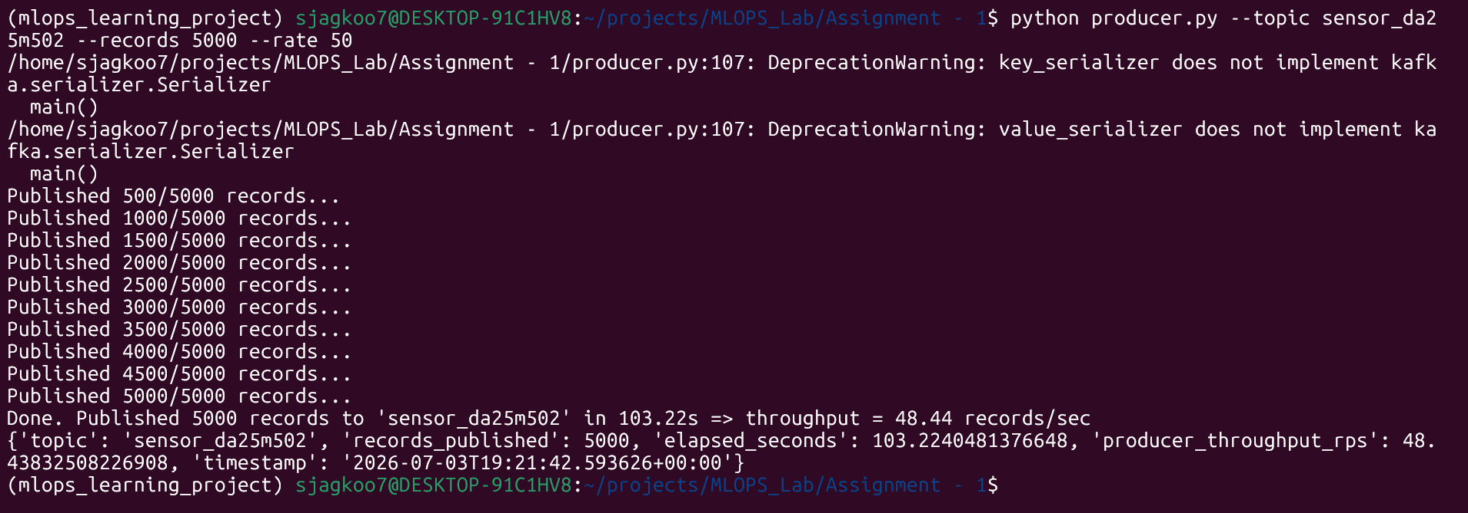

# 4. Consume the records from the topic and verify
python consumer.py --topic sensor_da25m502 --group group1 --bootstrap localhost:9092 --max-records 5000
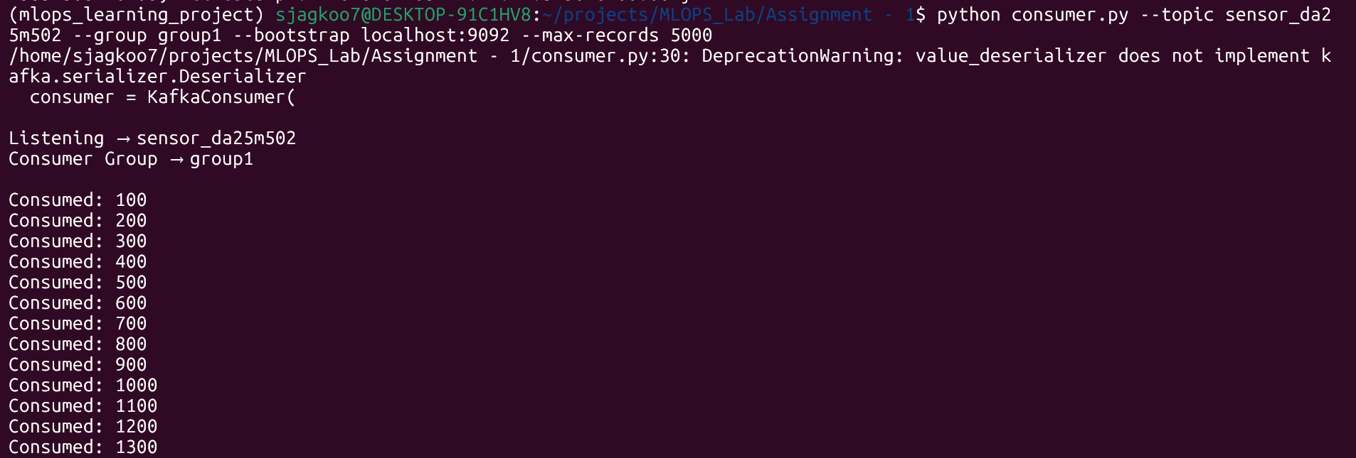


# 5. Metrics
Consumer | Total number of records produced | Total number of records consumed | Number of records received from each partition | Producer throughput (records/sec) | Consumer throughput (records/sec)
One consumer | 5000 | 5000 | Partition 0: 2465  Partition 2: 2535 | 48.44 | 1013.43
Two consumers | 5000 | 5000 | Consumer 1: Partition 0: 2580  Consumer 2:  Partition 2: 2420 | 48.49 | 1497.18
Four consumers | 5000 | 5000 | Consumer 1:  Partition 0: 5000  Consumer 2:  Partition 2: 5000  Consumer 3 :2300  Consumer 4 : 2300 | 48.44 | Consumer 1:  100.52  Consumer 2:  1186.73  Consumer 3: didn’t come  Consumer 4: didn’t come

Note: the experiment I had tried using local docker -kafka setup, reg. four consumer, 4th should be idle however, in my case 3rd and 4th process half-half data then both went idle. reason i was trying to run in different terminal leading some time gap meanwhile some consumer was consuming the fast. So, it was getting auto-picked.

# 6. Demonstrate consumer scaling

# One consumer
It’s already tested as above attached details.

# Testing Two Consumers
Step 1: Terminal 1 and start the consumer:
python consumer.py --topic sensor_da25m502 --group scaling_group_2 --bootstrap localhost:9092 --max-records 5000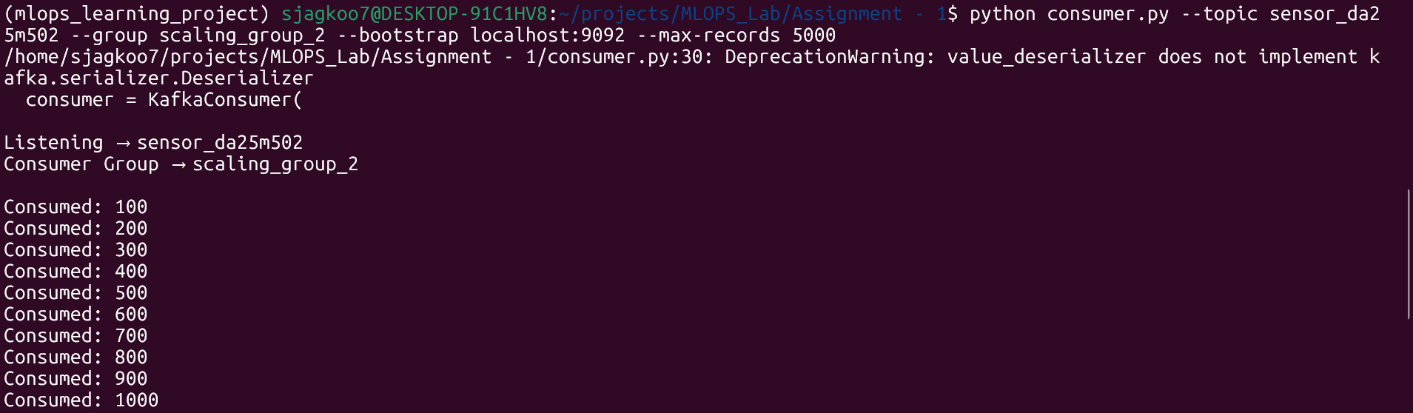
Step 2: Terminal 2 and start the producer:
python producer.py --topic sensor_da25m502 --bootstrap-servers localhost:9092 --records 5000 --rate 50
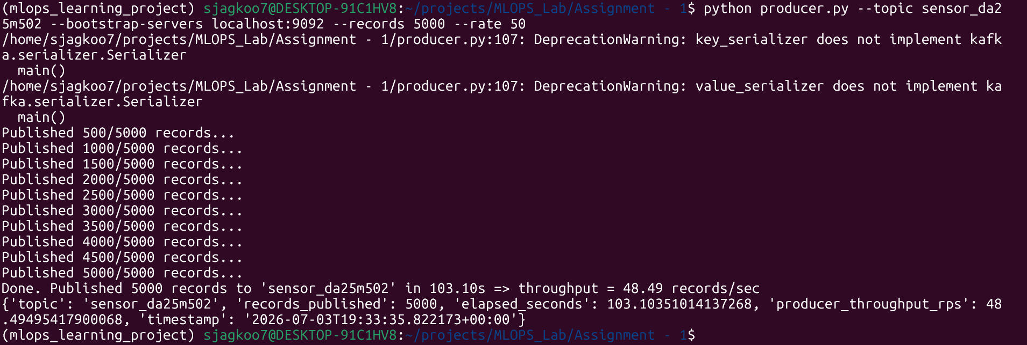

# Testing 4 Consumers
Four Terminal: Run this identical command in all four
python consumer.py --topic sensor_da25m502 --group scaling_group_4 --bootstrap localhost:9092 --max-records 5000
Terminal 1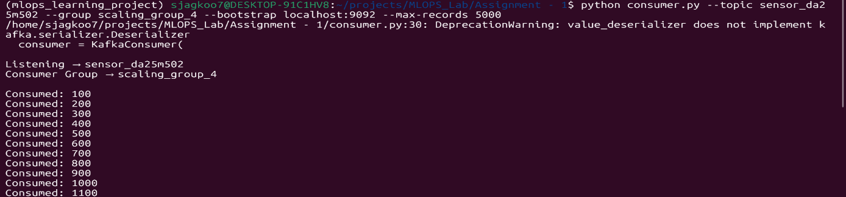

Terminal 2
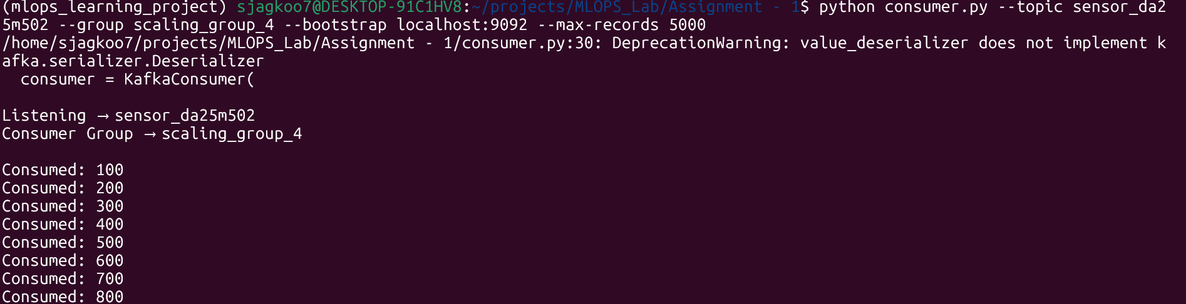


Terminal 3 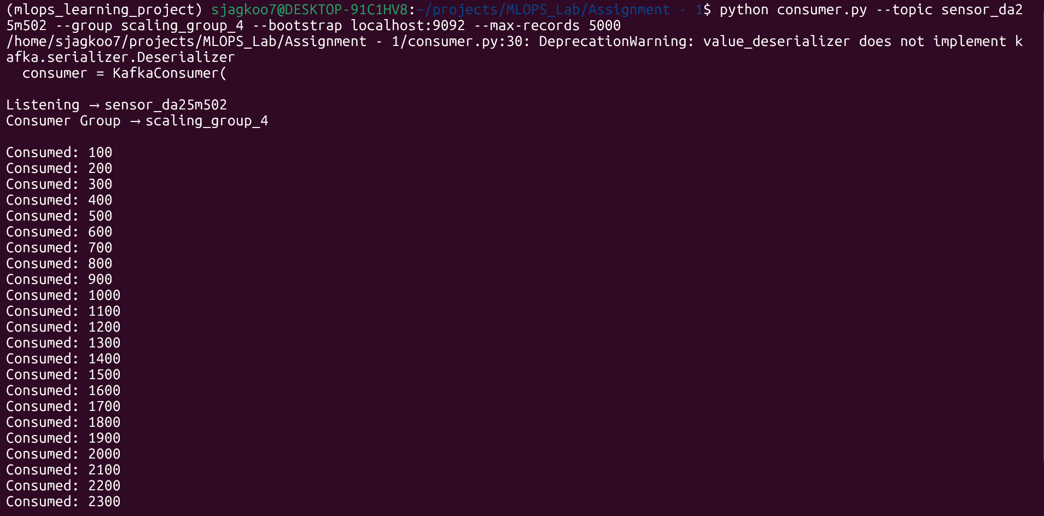
Terminal 4
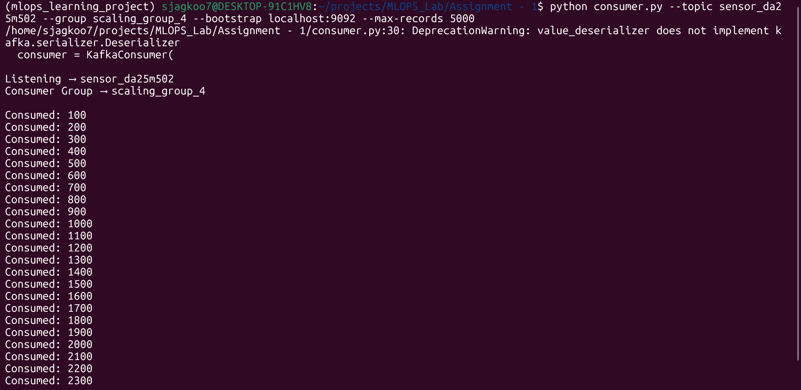
5th terminal window and triggered producer script again.
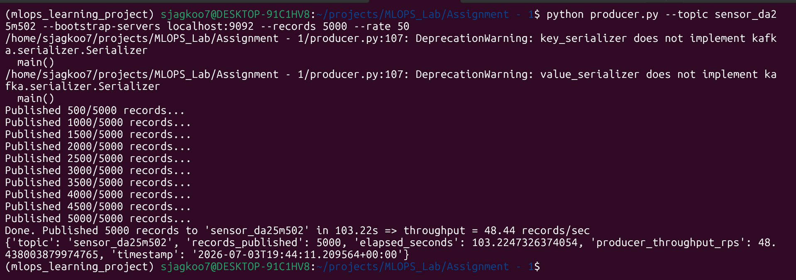
- Observation: Because we have 3 partitions but 4 consumers, one of your consumers will sit completely idle. Kafka can only assign a partition to a single consumer in a group at any given time.

# 7. Demonstrate independent consumer groups
Step 1 : Terminal 1 (Group A):
python consumer.py --topic sensor_da25m502 --group analytics_pipeline --bootstrap localhost:9092 --max-records 5000
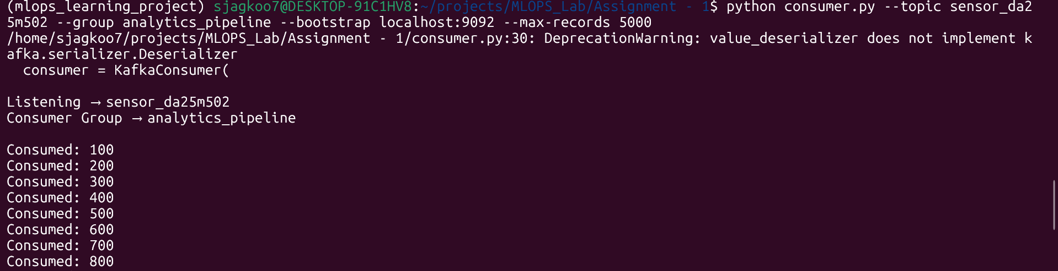
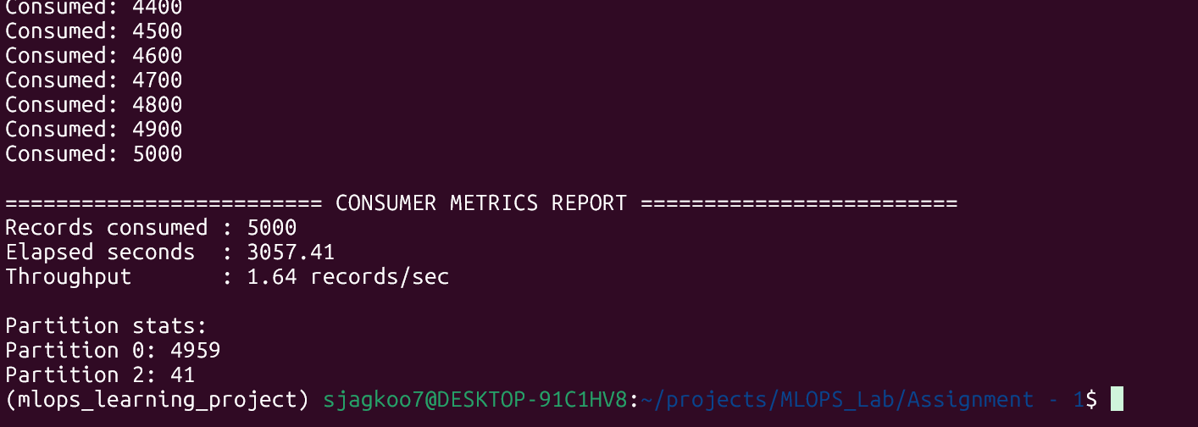
Step 2 : Terminal 2 Terminal 2 (Group B)
python consumer.py --topic sensor_da25m502 --group realtime_alerts --bootstrap localhost:9092 --max-records 5000
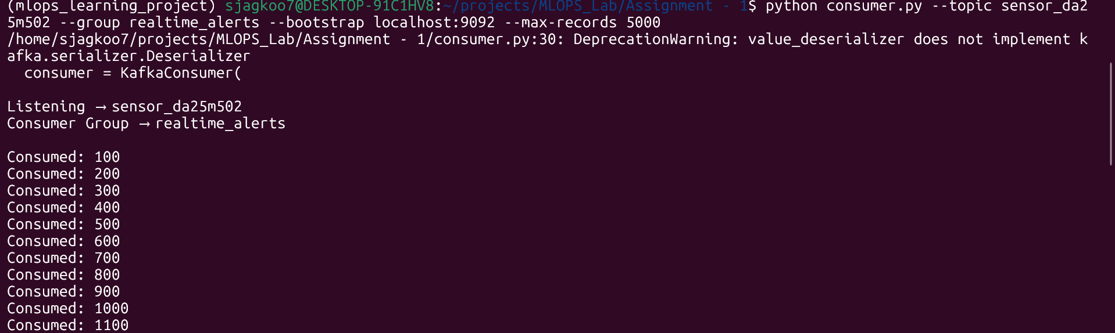
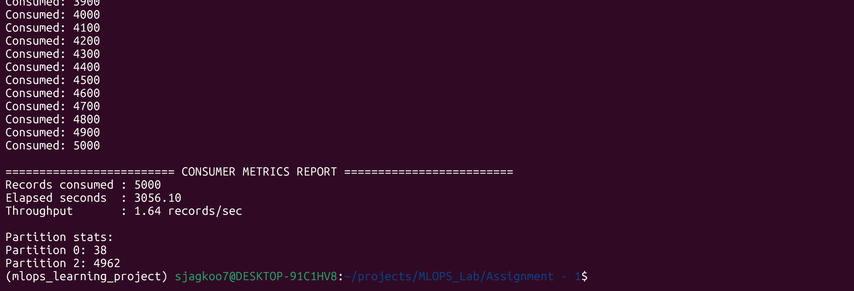
Step 3 : Terminal 3 - run the producer script.
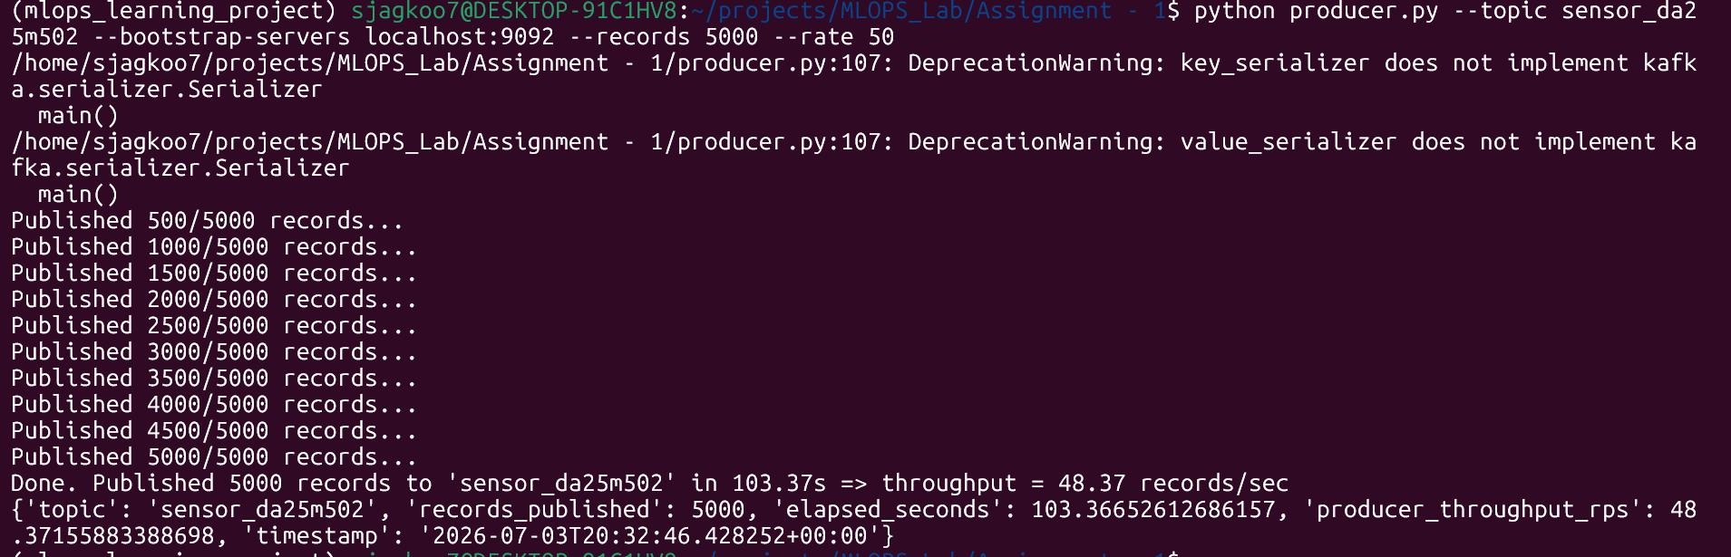

Discussion

The role of partitions in Kafka
Kafka does not store an entire topic as a single massive file on a machine. Instead, a Topic is split into multiple Partitions. Each partition is an ordered. Kafka allows different partitions of the same topic to be hosted on completely different brokers (servers)
Using `sensor_id` as the key keeps all records for a sensor ordered in the same partition.

Partitions and Consumer Parallelism
Within a single consumer group, Kafka guarantees that each partition is assigned to exactly one consumer instance at any given time. If we have a topic with 3 partitions, up to 3 consumers can read from it simultaneously in parallel, with each consumer handling exactly one partition.

More Consumers Than Partitions
Partitions should be always more than the number of consumers. Each consumer can process more than one partitions.
So that throughout will be high and optimal resource utilization, because if number of consumers are more than the partition the resource (consumers) will be idle.
In this example introducing 4th consumer where only 3 partitions are available.

